6.94: a) The number of cars is the total power available divided by the power needed per car,
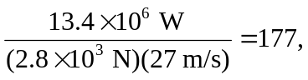

rounding down to the nearest integer.
b) To accelerate a total mass M at an acceleration a and speed v, the extra power needed is Mav. To climb a hill of angle , the extra power needed is 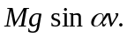 These will be nearly the same if 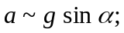 if 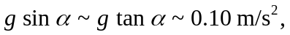 the power is about the same as that needed to accelerate at 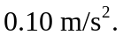
c) d) The power per car needed is that used in part (a), plus that found in part (c) with M being the mass of a single car. The total number of cars is then
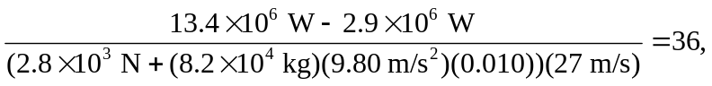
rounding to the nearest integer.

